# IMPLEMENT A MAPREDUCE PROGRAM TO PROCESS A WEATHER DATASET

**AIM:**

To implement a MapReduce python program to process a weather dataset in Hadoop.

# PROCEDURE:

1. Open command prompt as administrator and start the Hadoop by using the command.

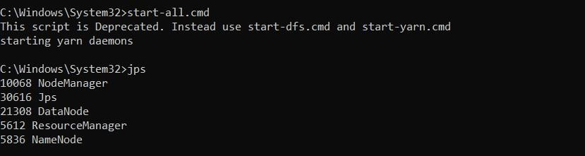

1. Create a new directory in the Hadoop file systems using the command and Upload the input text file into the weather directory using the command.





1. Create the mapper and reducer files.
2. To execute the files with Hadoop streaming run the following command.

C:\Windows\System32>hadoop jar "C:\hadoop\share\hadoop\tools\lib\hadoop- streaming-3.3.6.jar" ^-input /weather_ex3/sample_weather.txt ^-output

/weather_exerer3 ^-mapper "python C:\Users\Manoj\Desktop\weather\mapper.py" ^-reducer "python C:\Users\Manoj\Desktop\weather\reducer.py"

# MAPPER.PY:

import sys def map1():

for line in sys.stdin:

tokens = line.strip().split() if len(tokens) < 13:

continue

station = tokens[0]

if "STN" in station: continue

date_hour = tokens[2] temp = tokens[3] dew = tokens[4] wind = tokens[12]

if temp == "9999.9" or dew == "9999.9" or wind == "999.9": continue

hour = int(date_hour.split("_")[-1])

date = date_hour[:date_hour.rfind("_")-2] if 4 < hour <= 10:

section = "section1" elif 10 < hour <= 16:

section = "section2" elif 16 < hour <= 22:

section = "section3" else:

section = "section4"

key_out = f"{station}_{date}_{section}" value_out = f"{temp} {dew} {wind}" print(f"{key_out}\t{value_out}")

if name == " main ": map1()

# REDUCER.PY:

import sys def reduce1():

current_key = None

sum_temp, sum_dew, sum_wind = 0, 0, 0

count = 0

for line in sys.stdin:

key, value = line.strip().split("\t")

temp, dew, wind = map(float, value.split()) if current_key is None:

current_key = key if key == current_key:

sum_temp += temp sum_dew += dew sum_wind += wind count += 1

else:

avg_temp = sum_temp / count avg_dew = sum_dew / count avg_wind = sum_wind / count

print(f"{current_key}\t{avg_temp} {avg_dew} {avg_wind}") current_key = key

sum_temp, sum_dew, sum_wind = temp, dew, wind count = 1

if current_key is not None: avg_temp = sum_temp / count avg_dew = sum_dew / count avg_wind = sum_wind / count

print(f"{current_key}\t{avg_temp} {avg_dew} {avg_wind}") if name == " main ":

reduce1()

# OUTPUT:

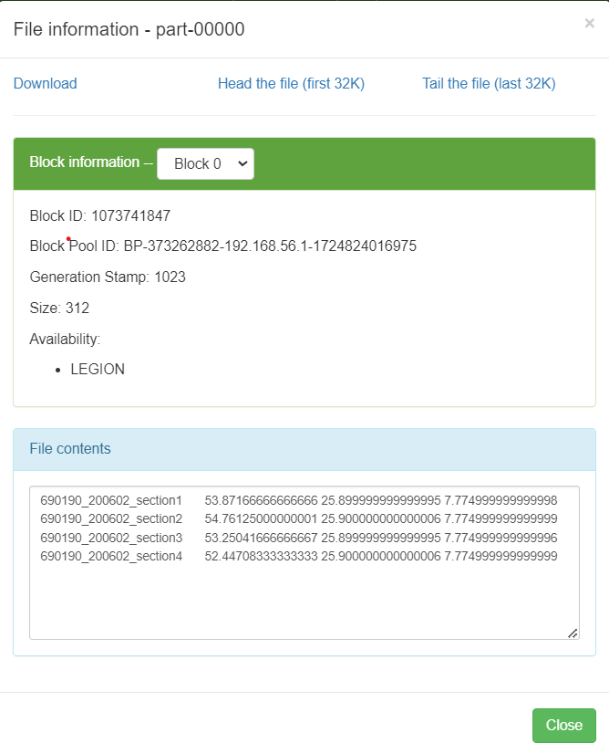

**RESULT:**

Thus the implementation of the MapReduce python program to process a weather dataset in Hadoop is executed successfully.